Project Name: Bus Times

Basic Details:

Team Name: Power Group

Members:

Jesna Joy- TocH Institute of Science and Technology

Jipindev M- TocH Institute of Science and Technology

Elson Biju- TocH Institute of Science and Technology

Project Description: Private bus time tracker

The Problem: Erratic arrival time of private bus owners

The Solution: Time Tracker

Technologies/Components used

For Software

* HTML
* CSS
* JAVA SCRIPT

Implementation: Releasing the Software live

Installation:

!DOCTYPE html>

<html lang="en">

<head>

    <meta charset="UTF-8">

    <meta http-equiv="X-UA-Compatible" content="IE=edge">

    <meta name="viewport" content="width=device-width, initial-scale=1.0">

    <link href='https://unpkg.com/boxicons@2.1.4/css/boxicons.min.css' rel='stylesheet'>

    <link rel="stylesheet" href="style.css">

    <title>Ludiflex | Time to Go</title>

    <style>

        body {

            font-family: Arial, sans-serif;

            margin: 0;

            padding: 0;

            background-color: #f0f0f0;

            display: flex;

            flex-direction: column;

            align-items: center;

            justify-content: center;

            height: 100vh;

        }

        .nav {

            width: 100%;

            background-color: #3f9896;

            padding: 10px 20px;

            color: white;

            display: flex;

            justify-content: space-between;

            align-items: center;

            position: absolute;

            top: 0;

        }

        .nav-logo p {

            margin: 0;

            font-size: 1.5em;

        }

        .nav-menu ul {

            list-style: none;

            padding: 0;

            display: flex;

        }

        .nav-menu li {

            margin: 0 10px;

        }

        .nav-menu a {

            color: white;

            text-decoration: none;

            font-size: 1em;

            transition: color 0.3s ease, transform 0.3s ease;

        }

        .nav-menu a:hover {

            color: #FFD700;

            transform: scale(1.1);

            text-decoration: underline;

        }

        .text-container {

            display: flex;

            flex-direction: column;

            align-items: center;

            margin-top: 60px; /\* Space below the nav \*/

        }

        #clock {

            color: black; /\* Change clock color to black \*/

            font-size: 4em; /\* Match the size of the big text \*/

            margin-bottom: 20px; /\* Space between the clock and text \*/

        }

        .big-text {

            font-size: 4em; /\* Keep the original size \*/

            color: #333;

            text-align: center; /\* Center align the big text \*/

            margin: 0; /\* Remove margin \*/

            transition: transform 0.3s ease;

        }

        .big-text:hover {

            transform: scale(1.1);

            cursor: pointer;

        }

    </style>

</head>

<body>

    <nav class="nav">

        <div class="nav-logo">

            <p>TIME TO GO.</p>

        </div>

        <div class="nav-menu" id="navMenu">

            <ul>

                <li><a href="#" class="link active">HOME</a></li>

                <li><a href="Bustimng.html" class="link">BUS TIMINGS</a></li>

                <li><a href="ABOUT.HTML" class="link">ABOUT</a></li>

                <li><a href="CONTACT.HTML" class="link">CONTACT</a></li>

            </ul>

        </div>

    </nav>

    <div class="text-container">

        <div id="clock"></div> <!-- Clock Placeholder -->

        <div class="big-text">

            TIME TO GO

        </div>

    </div>

    <script>

        function updateClock() {

            const now = new Date();

            const hours = String(now.getHours()).padStart(2, '0');

            const minutes = String(now.getMinutes()).padStart(2, '0');

            const seconds = String(now.getSeconds()).padStart(2, '0');

            const timeString = `${hours}:${minutes}:${seconds}`;

            document.getElementById('clock').textContent = timeString;

        }

        setInterval(updateClock, 1000); // Update the clock every second

        updateClock(); // Initial call to display the time immediately

    </script>

</body>

</html>

Run:

VS Code live server

Project Documentation

First we built a web page using html then we added background pictures, contact, bus time , about . For the modification we also added a digital clock that help us to know the time of bus and time taken of bus and we also implemented count on timer for estimate arrival of the bus.

Screenshot:

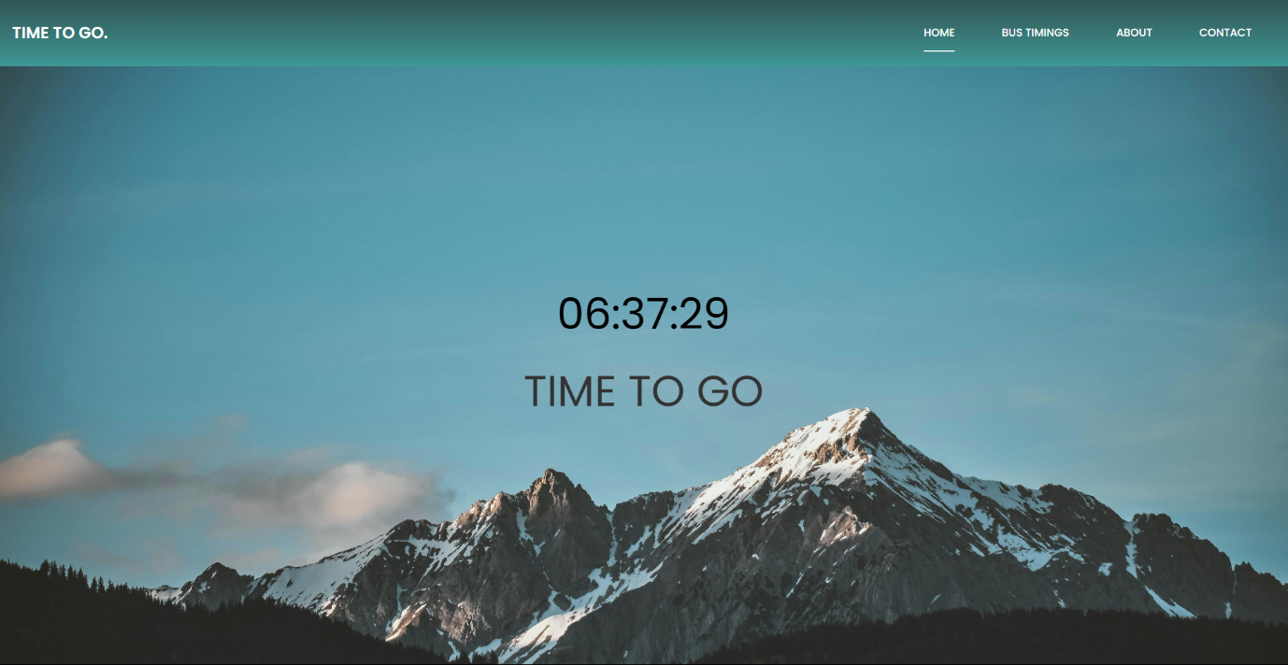

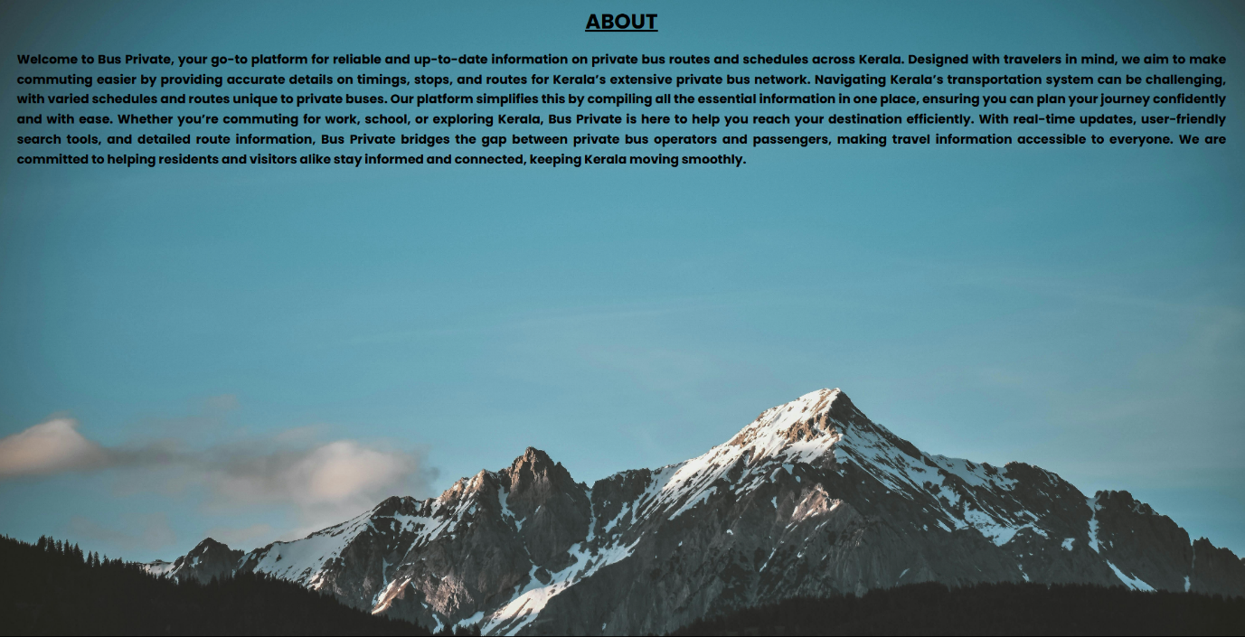

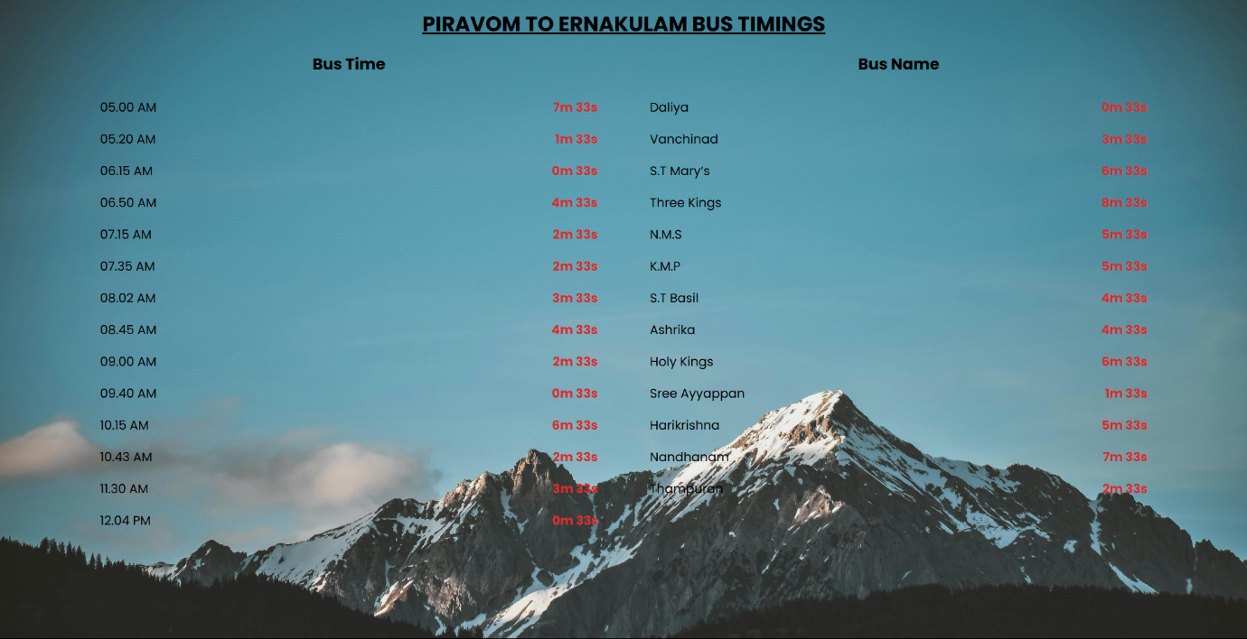

Video:



Team Contributions:

* Jesna Joy :- project idea
* Jipindev M :- coding
* Elson Biju :- project documentation